Note: This handbook contains new guidelines for EIS graduation requirements in accordance with motions passed by faculty in May 2019. Students who matriculated prior to Fall 2022 should follow the guidelines for degree requirements as outlined from their first year of the program.
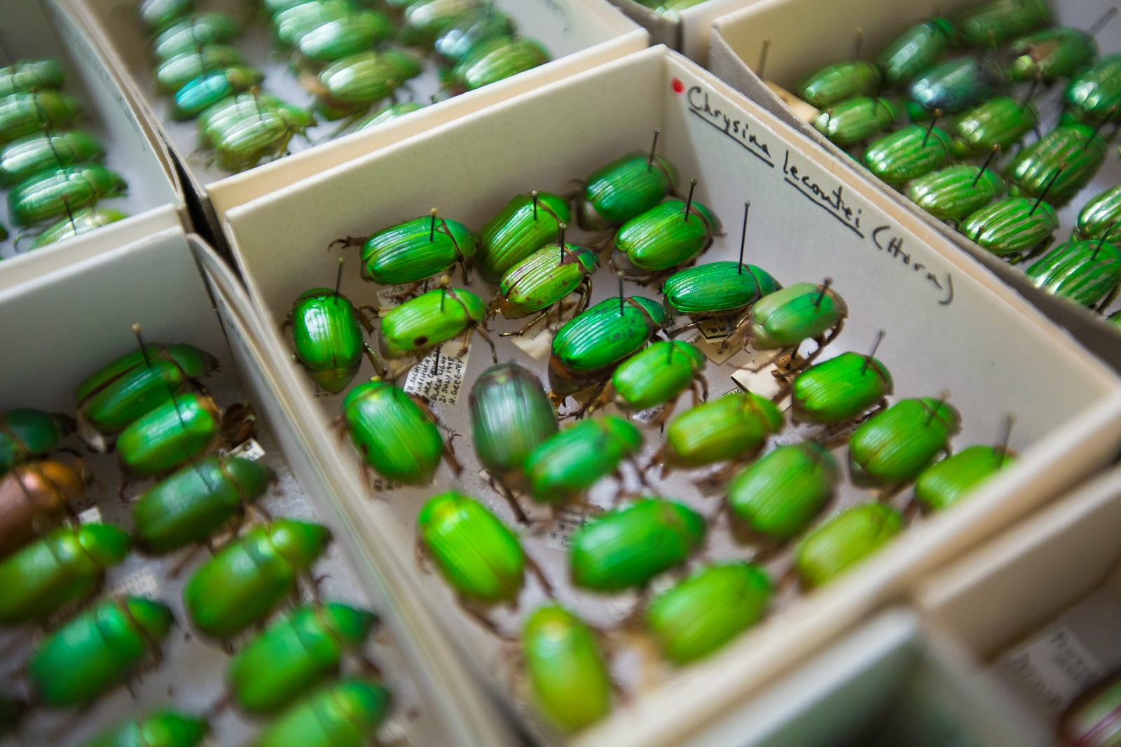
2025 - 2026
Graduate Interdisciplinary Program in Entomology and Insect Science

Student Handbook

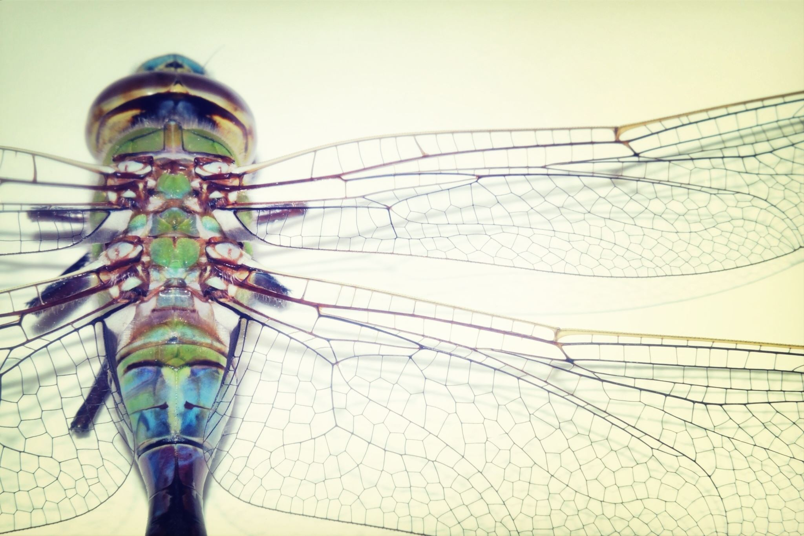
TABLE OF CONTENTS

Welcome 1
Using this Handbook
Contacts & Physical Resources and Facilities
About the EIS Program
Student Participation in Program Administration
Student Rights and Responsibilities
Advising and Progress 4
Expectations for Satisfactory Academic Progress
Advisors
Annual Progress Report
Graduate Committees
Advisory Committee Progress Reports
EIS Program Requirements 6
Enrollment Policy
Courses and Registration
Required Courses
Seminars and Group Meetings
GradPath
Learning Outcomes Assessment
Entomology & Insect Science PhD Student Requirements 10
Required Core Coursework:
EIS courses available to PhD majors
Popular courses available to EIS PhD majors
Steps to your Entomology & Insect Science PhD Degree 13
Choosing a Graduate Committee
GradPath Forms
Comprehensive Examination
Advancement to Candidacy
Dissertation and Final Examination
Exit Interview
Suggested Entomology & Insect Science PhD Timeline
Entomology & Insect Science MS Student Requirements 17
Required Core Coursework:
EIS courses available to EIS MS majors
Popular courses available to EIS MS majors
Steps to your Entomology & Insect Science MS Degree 19
Choosing a Graduate Committee
GradPath Forms:
Plan of Study
Final Examination
Exit Interview
Suggested Entomology & Insect Science MS Timeline
Steps for EIS MS student to transfer to the EIS PhD Program
Entomology & Insect Science Minor Student Requirements 22
Required Core Coursework
EIS courses available
Financial Information 23
Entomology and Insect Science Program funding
Mandatory start of semester fees
Multiple Means of Support
Additional Funding Opportunities
Important Links 27
Academic Resources
Graduate
Personal Resources
Entomology & Insect Science Resources 29
Keys
University of Arizona Insect Collection (UAIC)
Meeting rooms
Seminars
Listservs
Graduate Student Learning Outcomes Assessment 30
Appendix 1: Student Appeals 31
Graduation Requirements
Course Grades
Unsatisfactory Academic Progress
Grievance Policy
Appendix 2: Progress Report Format 32

Welcome

Welcome to the Graduate Interdisciplinary Program in Entomology and Insect Science (GIDP-EIS). During your time in the program, whether as a master’s or Doctoral candidate, you are encouraged to bridge scientific disciplines in ways that bring fresh perspectives to questions in insect biology. The program faculty is here to assist you in developing your individualized degree program and in designing and accomplishing your research. So, welcome, and best of luck with your graduate training.

Using this Handbook
This handbook describes the Program's current regulations and procedures, as well as the various requirements that must be met for the PhD and MS degrees. Please use the links provided in this handbook to review up-to-date information on Graduate College and EIS GIDP policies. It is GIDP policy that the student holds final responsibility for being aware of and responding to all GIDP and Graduate College policies, requirements, formats, and deadlines as they pertain to progression towards and completion of their degree.

If you have any questions about the program, please contact the GIDP-EIS Graduate Program Coordinator, Paula Nielsen pnielsen322@arizona.edu

Contacts & Physical Resources and Facilities

Mike Riehle, Chair  GIDP in Entomology & Insect Science  Marley Building, 641  (520) 626-9350  mriehle@ag.arizona.edu | Paula Nielsen, Graduate Program Coordinator  GIDP in Entomology & Insect Science  Marley Building, 641C  (520) 621-0847  pnielsen322@arizona.edu
Alyssa Takagi, Graduate Degree Counselor  Graduate College, University of Arizona  amtakagi@arizona.edu  (520) 626-9962 | Graduate Student Representative  Please check EIS website for current student representative
EIS Breakroom – Marley 6th Floor | EIS Mailroom (Forbes 410)  Entomology and Insect Science  c/o Department of Entomology  1145 E. 4th St., PO Box 210036  Tucson, AZ 85721-0036

About the EIS Program
The Graduate Interdisciplinary Program (GIDP) in Entomology and Insect Science (EIS) offers Master of Science and Doctor of Philosophy degrees. The faculty of the EIS GIDP currently includes members representing seven departments: Entomology, Ecology and Evolutionary Biology, Epidemiology, School of Natural Resources and the Environment, Neuroscience, Molecular and Cellular Biology Geography. For an updated list of faculty and their research interests, please refer to the EIS Program website.

In addition to coursework and research opportunities, EIS Graduate students also have access to a variety of seminars, workshops, and conferences sponsored by the EIS GIDP, the Dept. of Entomology, the Graduate College and other programs and organizations on campus.

What is a GIDP?
Graduate Interdisciplinary Programs or GIDPs are PhD, Masters, and minor programs with collaborative relationships between all colleges across campus creating unique opportunities in interdisciplinary research. GIDPs transcend departmental boundaries by facilitating cutting edge teaching and research at the nexus of traditional disciplines. The high value placed on interdisciplinary research and education is indicative of The University of Arizona's enthusiasm and commitment to fostering innovation and creativity among its faculty and students.

To learn more about other GIDPS at the University of Arizona visit the GIDP website

Affiliation
EIS students’ affiliation (for publications or presentations) is “Graduate Interdisciplinary Program in Entomology and Insect Science, 1145 E. 4th St., PO Box 210036, Tucson, AZ 85721.” This is true even though your advisor (who may be a co-author on your work) has a separate departmental affiliation (e.g., Dept. of Entomology or Dept. of Ecology and Evolutionary Biology). The EIS program and the two programs that preceded it also have close relationships with the Department of Entomology, and the College of Agriculture & Life Sciences (the college in which Entomology is housed), and these institutions should be gratefully acknowledged for any funding granted. You may also claim dual affiliation in manuscripts with the department of your advisor.
The GIDP in Entomology and Insect Science is administered by an Executive Committee. The Executive Committee is chaired by the Program Chair and includes six faculty members and a student representative. The Executive Committee of the GIDP in Entomology and Insect Science formulates policies and procedures for the operation of the graduate program in such areas as admissions, curricula, student supervision, and completion of degree program requirements.
Program Committees
In addition to the Executive Committee, there are two other standing committees for the program. The Admissions Committee coordinates all recruiting and admissions procedures. The Advisory Committee is relevant for current students. The Advisory (Progress) Committee solicits and evaluates annual progress reports from all students (more information on progress reports is available in Section 3, Advising and Progress).

Student Participation in Program Administration
At the end of each school year, the students in the EIS Graduate Program elect a Graduate Student Representative from among their peers to serve a one-year term, beginning the following fall.
The primary duties of the Graduate Representative are:

- To bring the questions and concerns of the students in the Program to the attention of the Program Chair, and vice versa.
- Help the Program management develop Program policy as needed.
- Assist with the organization of the annual recruitment workshop in the Spring semester and other Program activities when appropriate.
- Appoint student committee members for EIS Awards in Education and Leadership (see Program Awards below).
EIS GIDP students are encouraged to work with the Executive Committee to improve any aspect of the Program, including, but not limited to, examinations, application processes, course requirements and electives, and research and funding opportunities. To ensure that messages are not lost, students should direct comments through the Graduate Representative. If there is a conflict of interest or some other complication that prohibits this path of action, please contact the EIS Program Coordinator to discuss.

Program Retreat
The EIS GIDP has historically hosted a program retreat, in the spring of every other year, and hope to start this again post-pandemic. Potential changes to program policy and activities are discussed by attending students and faculty. Student input is valued. Faculty then break off and settle on proposed motions for program changes. Motions are put forth to all EIS faculty for a vote. All changes to EIS GIDP policy will be promptly shared with students via the student email listserv.

Student Rights and Responsibilities
Responsibility for meeting EIS GIDP and University requirements ultimately rests with the student – students should not expect reminders of deadlines from the program.

Students are entitled to the following rights as members of the EIS GIDP:

- Right to representation through an elected Graduate Student Representative
- Right to appeal as outlined in Appendix 2: Student Appeals
- Right to understandable information on all degree requirements
- Right to understandable information on program progress through:
  - consistent assessments,
  - meetings with faculty advisors at least once per semester, and
  - timely feedback (maximum 6 week turn-around) on degree requirements,
- Right to prompt notification of changes in Program policy via the student listserv
Students are responsible for making Satisfactory Academic Progress (Appendix 1) and meeting the other expectations of the Graduate College and the EIS GIDP as outlined in this Handbook.
EIS students are also expected to abide by all relevant ethical and academic standards of the University as outlined below.

- Academic Integrity
- Responsible Conduct of Research
- Graduate College Academic Policies

Advising and Progress
Student advisors, Graduate Committees, and the Advisory Committee work together to ensure that students stay on track to degree completion. Students are expected to meet with their committees and to complete progress reports annually.

Expectations for Satisfactory Academic Progress
A student making satisfactory academic progress maintains a 3.0 GPA in program courses and is making timely progress on the steps to their degree as outlined in this handbook.

Failure to Achieve Satisfactory Progress
In the rare circumstances that a student fails to meet program guidelines for satisfactory progress, the student will receive written notification with a clear statement of what the student must do and a date by which such actions must be completed. The Graduate College will receive a copy of letters of unsatisfactory progress. Students will be given an opportunity to appeal or rebut, as described in Appendix 2: Student Appeals. Students who fail to improve by the deadlines specified may be dismissed from the program.
Advisors
You will meet with your advisor frequently during your program. Students generally come in with an advisor, but in the unusual circumstance that they are considering more than one faculty member as an advisor, they should select an advisor before the start of the second semester of study. This selection will be influenced by discussion with the potential advisor, research rotations, and individual meetings with the Program faculty.

If you are an undecided first year student, communicate with the faculty whose laboratories you are considering joining to make sure they are also willing to advise you. Please check the degree requirements and tracking in GradPath to make sure you stay moving ahead in your degree progress.

Annual Progress Report
Annual progress reports are required from all current students. Progress reports are generally due at the end of May, after the second semester has concluded – students will receive a notification in the Spring semester on the deadline for progress reports. The Advisory committee then meets to discuss all the student reports. Each student and their advisor receive a letter with a summary of the Committee’s thoughts and concerns. When there's concern about the progress of a student, the report and letter from the Committee will be forwarded to the EIS Chair for further discussion with the student and advisor. Copies of all letters from the Advisory Committee will be filed with the Executive Committee and with the students’ files. If students fail to make progress in successive years, the student may be consulted and then notified of milestones that must be reached by certain dates (see failure to achieve satisfactory progress, above). In rare circumstances, the Advisory Committee may recommend probation or dismissal.
The format for annual progress reports is available in Appendix 2.

Graduate Committees
Who can serve and what do they do?
The Graduate Committee, with your major advisor, will: (1) advise you on preparation of a Plan of Study, (2) supervise your research (3) conduct the comprehensive examination, and (4) evaluate and edit the dissertation and conduct the final examination and dissertation defense.

Students should select a Graduate Committee in the first year, before the start of the third semester of study. This selection will be influenced by discussions with your advisor and individual meetings with the Program faculty. If you are considering inviting a particular faculty member for your committee, you should establish a time to meet, and then plan to discuss your research plans, and ask whether they would be willing to serve on your Graduate Committee.

Note: Graduate Committees may change over the course of a student’s program. Changes may occur because of a change of the student’s research focus, the departure of a faculty member to another institution, or, rarely, because of a conflict with a committee member.

Who can serve on your committee? Committee member requirements are available on the Graduate College website

In addition to the yearly committee meetings required, it is highly advisable to schedule a committee meeting when the thesis or dissertation has taken shape and the end is in sight (e.g., the semester before you defend). Present the research that will be in the final thesis/dissertation to your committee at this time and make sure that all members approve of the scope, rigor, and organization of the final product. At this time, your committee can decide when it requires a final draft of the paper to review. At minimum, committees generally require the complete and formatted thesis/dissertation two weeks before the defense.

Advisory Committee Progress Reports
Annual progress reports are required from all current students. They are generally due at the end of May, after the second semester has concluded. The Advisory committee then meets sometime during the summer to discuss all the student reports. Each student and their advisor will receive a letter with the summary of the Committee’s thoughts and concerns. When there's concern about the progress of a student, the report and letter from the Committee will be forwarded to the EIS Chair for further discussion with the student and advisor. Copies of all letters from the Advisory Committee will be filed in the students’ files. If students fail to make progress in successive years, the Advisory Committee may recommend probation or termination.

The Graduate Coordinator will send out requests for progress reports in the spring semester. A sample format for the progress reports is available in Appendix 3.

EIS Program Requirements

Enrollment Policy
- With the exception of students in their last year who may take fewer credits, students ordinarily take between six (minimum) and 12 (maximum) units of graduate course work in each fall and spring semester to remain in good standing in the Program. Work with your Major Advisor and the EIS Program Coordinator to make sure you are enrolled for the right number of units. International students may need to take a certain number of units to fulfil their visa requirements.
- MS students may register for 1-8 units of EIS 900 Research and/or EIS 910 Thesis per semester. PhD students may register for 1-9 units of EIS 900 Research and/or EIS 920 Dissertation per semester. By the end of your program, MS students need 8 units of EIS 910 Thesis credits and PhD students need 18 units of EIS 920 Dissertation credits. When you are taking less than a full load of graded courses, your enrollment will consist of mainly these two types of units.
- These policies are subject to change. Please refer to University Enrollment Policies for current information.
- See more specific details in the paragraphs below.

Courses and Registration
All EIS students will start their program with some required courses taken in the first or second year. There are few of these, but because they are generally offered only once in a two-year cycle, you will need to take them when they are offered. After that time, you will select your courses in consultation with your Advisor and Graduate Committee. PhD students will also select a minor and complete minor requirements. You will also need to meet the Graduate College requirements for your program. However, you will find that you have a great deal of flexibility to choose the courses most relevant to your interests and research direction.

A complete list of Entomology and EIS courses are available on the Registrar’s website, but any graduate level course approved by your committee can be considered, and our students take courses in programs across campus, including in Ecology & Evolutionary Biology, Molecular and Cell Biology, Epidemiology, School of Natural Resources and the Environment, Plant Sciences, GIDP in Neuroscience, Geography, and others.

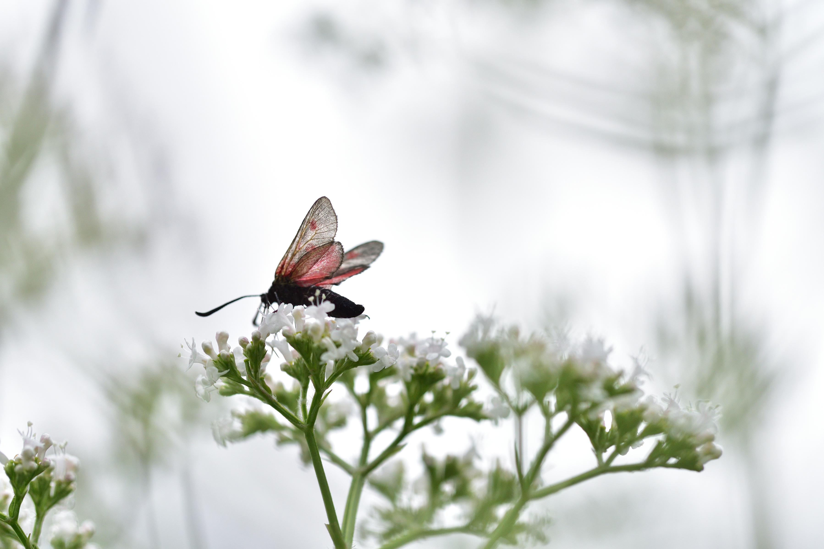

 | - View the Schedule of classes by semester.  - Put in EIS (or other prefix) under Subject Area and click Search.  - If you wish to see the course description, click on the link under Section.  - See more information about the courses below and pay careful attention to the checklist that follows.

Letter Grade vs Non-Letter Grade and Schedule Changes

- Courses for a letter grade can be added online through UAccess.

- Non-letter grade enrollment can consist of Independent Study, Laboratory Rotation, or Research units (including dissertation and thesis).
- Non-letter grade units can be added by submitting an email request to the EIS Graduate Coordinator. Please include the desired course number, number of units, and supervising instructor in your email. Please confirm your plans with the supervising instructor prior to making the request.
- Deadlines exist for all schedule changes. Please be aware of these important deadlines by checking the Registrar’s website.

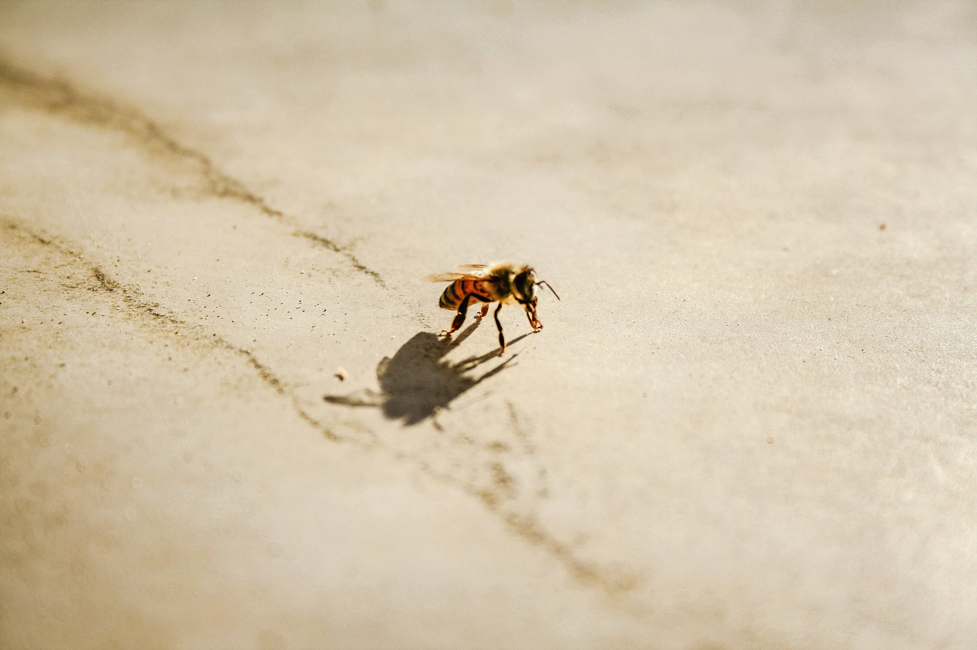

Required Courses
EIS 596A, Current topics in Entomology & Insect Science (Seminar)

The program seminar has a different format in fall and spring. In the fall students read on the topic of their planned thesis or dissertation topic and write weekly summaries of their reading. During class period, students present papers they’ve read, with all students presenting at least twice during the semester. Students also discuss the joint Entomology/EIS seminar series talk of the previous week. The spring seminar is for proposal writing. Students work throughout the semester in writing a draft of their MS or PhD proposal, with class periods being devoted to discussion of scientific writing, peer reviews and sharing progress. PhD students are required to take fall & spring semester offerings in both their 1st and 2nd year in the program. MS students are required to take the fall and spring seminar in their 1st year in the program.

EIS 792, Research Rotation

During the first year in the EIS program, each PhD student must complete at least two laboratory rotations, one of which must be conducted in a laboratory other than that of the student’s advisor. Laboratory rotations count for course credit. Lab rotations encourage you to have hands-on experience in areas of interest, to learn research methods in the field and to become acquainted with the laboratory work and research group of prospective dissertation advisors.

You will earn 3 units per semester for a maximum of 9 possible units earned for rotation. The length of rotations is 8 weeks, with about 10 hours of work per week expected in the lab. However, the rotation project can be continued beyond 8 weeks with the agreement of the student, rotation mentor, major advisor, and program coordinator. The number of units you earn is dependent on the number of rotations you do and the time it takes to complete each one. It is common to complete 1 & ½ rotations in a semester with the 2nd rotation beginning mid-semester, with completion taking place in the following semester (with or without a second semester of course enrollment). Students are encouraged to complete a third rotation if they like. Please note, you cannot register for rotation mid-semester, you must register prior to the semester start.

There is no set format for a given rotation project. Both the student and rotation host should design rotation projects to achieve specific goals for student development and expected outcomes for the project. Before the project begins, submit a rotation form to the EIS Program Coordinator. The rotation form is available on the EIS website. Do fill these out – they provide a clear plan and prevent misunderstandings or revisions of the scope of the rotation as it progresses.

At least two of three of the following core courses:

EIS 517, Insect Systematics (offered alternative years in the fall)
EIS 520, Insect Molecular Physiology (offered alternative years in the spring) *
EIS 544, Insect Ecology (offered alternative years in the fall)

*This course has not had sufficient enrollment to be offered in recent years.

Seminars and Group Meetings
Students are expected to participate actively in group meetings, seminars, and activities of the Program.

GradPath
Students are required to complete GradPath forms via UAccess as they progress through their degrees. Please review the GradPath requirements under your degree and complete forms by the stated deadlines. For additional information see GradPath User Guides

Learning Outcomes Assessment
Program assessment forms are used to evaluate and monitor strengths and weaknesses in learning of all students in the program; assessment forms are not used to grade or judge individual students. Learning outcome surveys will be linked to emails to students at the time of comprehensive exams (for PhD students) and final defenses (both MS and PhD students).

An explanation of the assessment process and the EIS program learning outcomes for both MS and PhD students can be found here: Graduate student learning outcomes assessment.

EIS program assessment self-reflection forms must be completed by students and graduate committee members for each of the following degree milestones:
- Oral Comprehensive Exams
- Final Thesis Exams/Dissertation Defenses

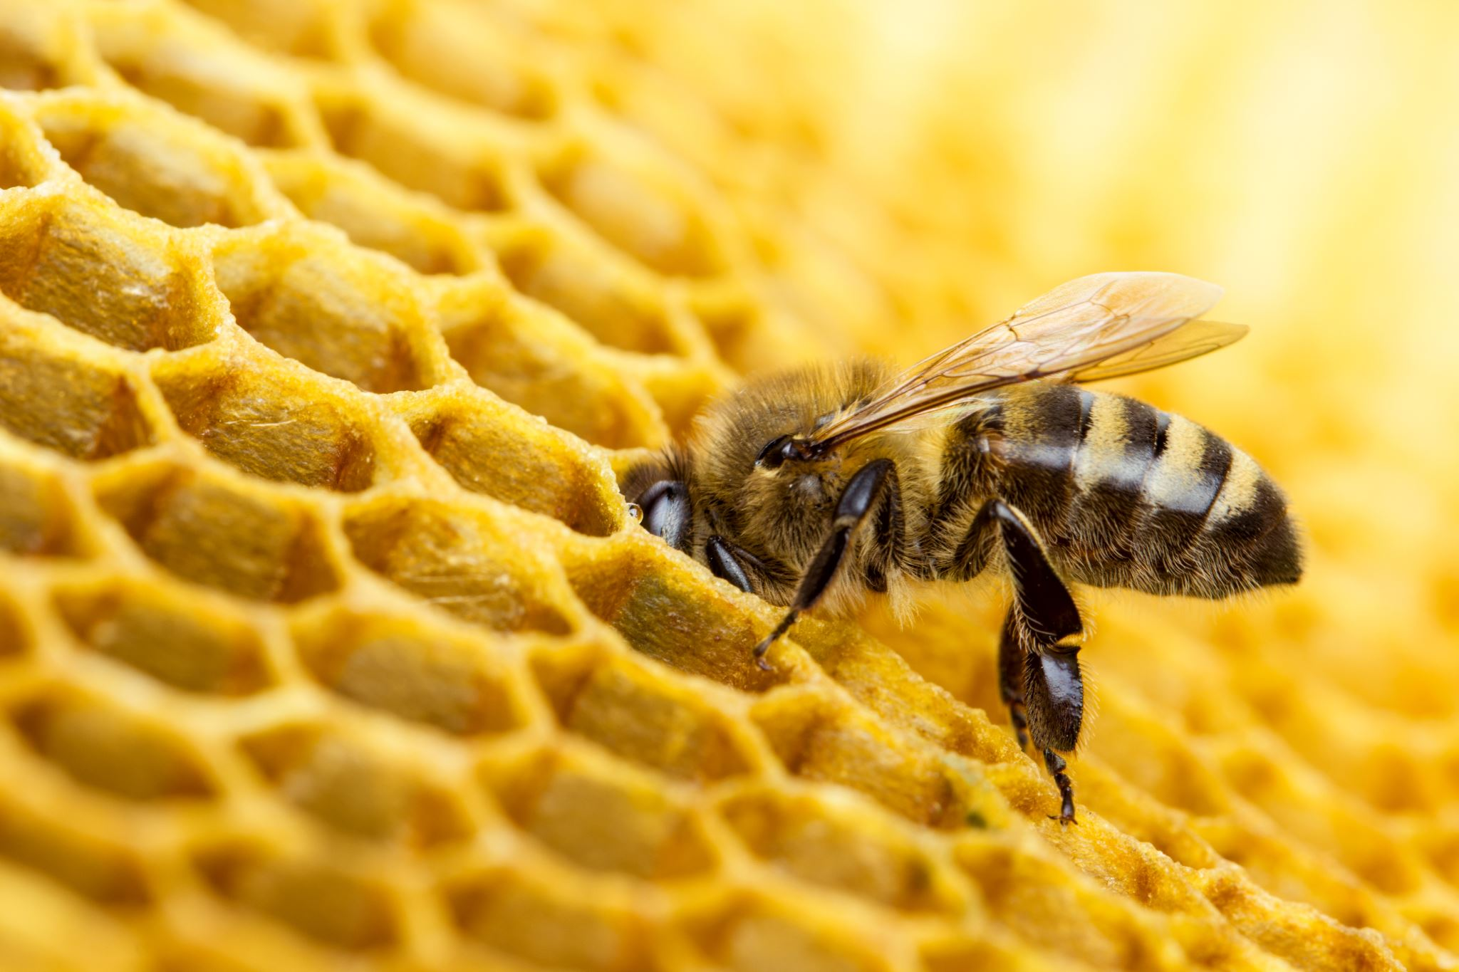

Entomology & Insect Science PhD Student Requirements
Please familiarize yourself with the Graduate College policies for doctoral students.



Required Coursework:
These courses are all offered alternate years, so students will take them in their first or second year.
Minimum credits for Major: 36
Minimum credits for Minor: 9
Minimum credits for dissertation: 18

Units will include EIS courses, courses in the minor, other courses chosen from the schedule of classes and approved by the Graduate Committee, and research and independent study units. Eligible transfer courses may also be included in this tally.
1. At least two of three of the following core courses:
- EIS 520 Insect Molecular Physiology (3 units) *
- EIS 544 Insect Ecology (3 units)
- EIS 517 Insect Systematics (4 units)

2. EIS 596A Current topics in Entomology & Insect Science Seminar (1 -3 units)
Course is taken four (4) times, fall & spring semester in the first and second year of the program.

3. At least two research rotations EIS 792 (3-6 units).
One rotation needs to be completed in a laboratory other than the advisor of record.

4. EIS 920 Dissertation (18 units).

5. PhD minor in a program other than EIS, consisting of at least 9 units.

* This course has not had sufficient enrollment to be offered in recent years.

EIS courses available to PhD majors

EIS PhD Student Requirements

EIS 501 | Ecological Physiology (3 units)
EIS 503C | Intro to Computational Neuroscience (
EIS 505 | Aquatic Entomology (4 units)
EIS 513 | Applied Biostatistics (3 units)
EIS 515R | Insect Biology (3 units)
EIS 532 | Comparative Immunology (3 units)
EIS 536 | Agro-ecology (3 units)
EIS 553 | Functional and Evolutionary Genomics (4 units)
EIS 557 | Medical-Veterinary Entomology (3 units)
EIS 588 | Principles of Cellular and Molecular Neurobiology (3 units)
EIS 597C | Controlled Environment Agriculture IPM (3 units)
EIS 599 | Independent Study (1 – 5 units)
EIS 660 | Infectious Disease Epidemiology (3 units)
EIS 699 | Independent Study (1 – 3 units)
EIS 900 | Research (1 – 8 units)
EIS 920 | Dissertation (1 – 8 units

In this interdisciplinary program, we encourage students to take courses in other programs that suit their developing interests, in consultation with their graduate committees.

Popular courses available to EIS PhD majors

BE 534 | Biosystems analytics (Python for data analysis)
BE 587 | Metagenomics
BIOS 576A | Biostatistics in public health
BIOS 576B | Biostatistics for research
ECOL 596W | Special topics in Ecology and Evolution: Practical and Reproducible data science
ECOL 530 | Conservation genetics
ECOL 528R | Microbial genetics
ECOL 506R | Conservation biology
ECOL 519 | Introduction to modeling in biology
ECOL 526 | Population genetics
ECOL 587R | Animal behavior
ECOL 600B | Fundamentals of ecology
ENVS 567 | Introductory statistics and multivariate statistics with R
EPID 573A | Basic principles of epidemiology
PLP 550 | Principles of plant microbiology
NRSC 572 | Neurodevelopment in action

Entomology & Insect Science PhD Student Requirements (continued)

Elective Coursework
In the fall students taking the required EIS 596A seminar course will attend Entomology/EIS research seminars and, separately, read the literature in their own area of research, write summaries and twice per semester, present a paper relevant to their own research in the class meeting time. The spring semester EIS 596A seminar course will be a structured proposal writing workshop, with frequent peers, advisor, and course instructor review of drafts.

Minor Requirements
Minors must be in a program or department other than EIS. Nine (9) units are generally required for a minor. A member of the minor department or program must serve on the student's graduate committee and approve the units taken for fulfillment of the minor.

Speaking Requirement
PhD students who have completed their comprehensive exams must present two talks on their research progress, one of which may be on campus. Attending and presenting at conferences are excellent opportunities to share research results and develop scientific communication skills.

Teaching Requirement
University level teaching is considered essential training for an academic career. Therefore, PhD students must serve as a Teaching Assistant or have an equivalent type of teaching experience for at least one semester sometime during their graduate program.

Time Limitation
PhD students must pass their Final Defense within 5 years of passing the Comprehensive Exam.

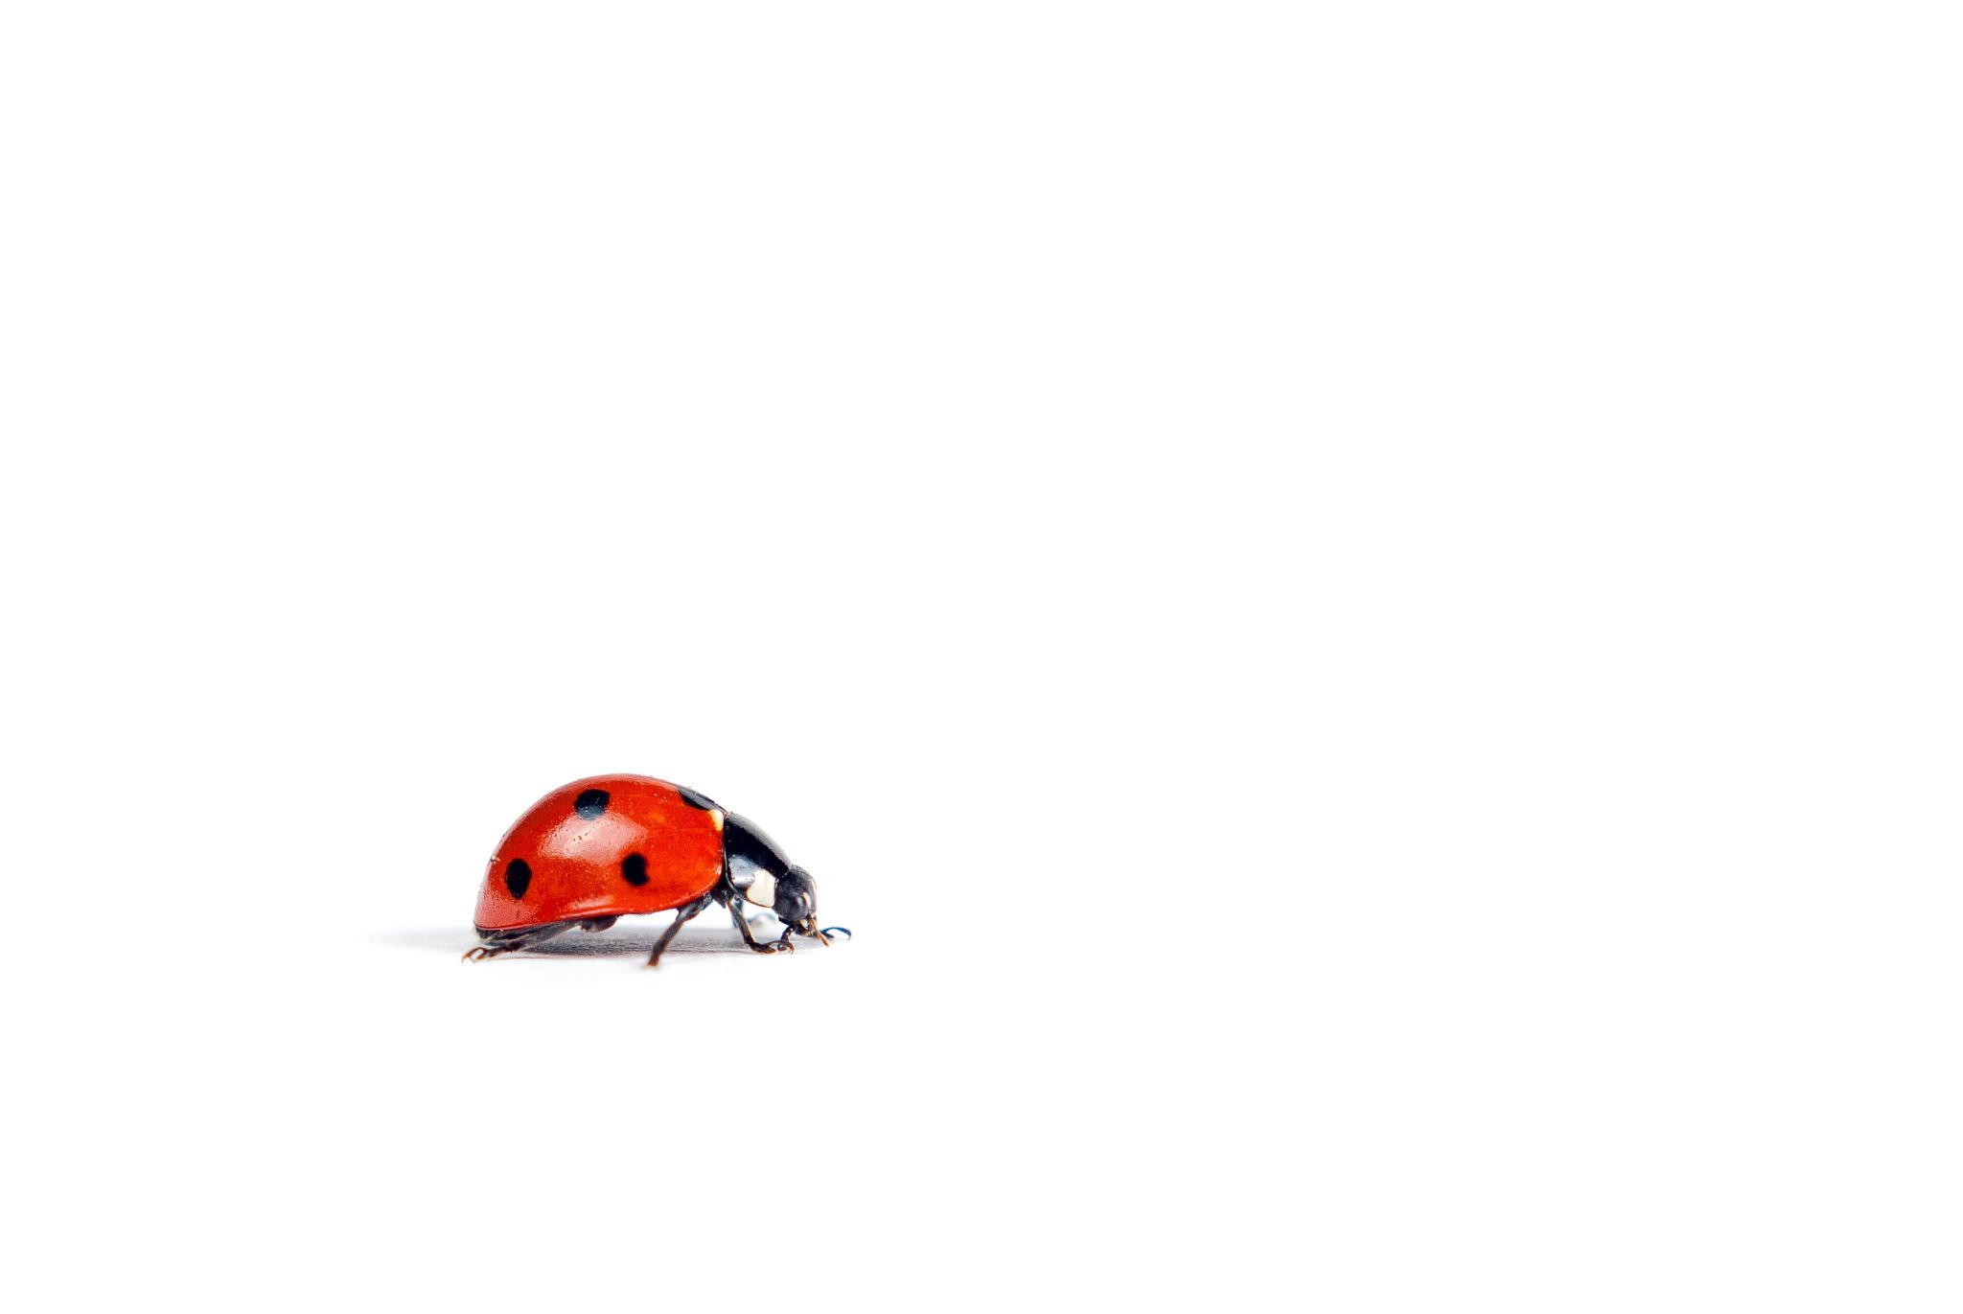

Steps to your Entomology & Insect Science PhD Degree

Choosing a Graduate Committee
The Graduate Committee must be chosen by the end of the second semester. The composition of your graduate committee must be submitted on GradPath. The Graduate College requires a minimum of three committee members to approve the dissertation, all of whom must be University of Arizona tenured, tenure-track, or equivalent. The fourth and fifth members, if any, may be UA faculty or approved special members. Things to keep in mind:

- It's best to have a minimum of 4. This is helpful if a committee member can't attend meetings or the dissertation defense. However, 5 or more members may have logistical difficulty in scheduling.
- Three members must be regular faculty at the University of Arizona; however, it is possible to include a 4th person as a “Special Member” if that person has special skills and knowledge. A request must be submitted to the Graduate College for a “Special member”. The request requires basic information and a CV for the proposed committee member.
- In GradPath there is a distinction between the Comprehensive Exam Committee and Doctoral Dissertation Committee. This means that a change in committee is possible. All changes must be entered into GradPath.
- Please see more details about PhD Graduate Committees.

GradPath Forms
GradPath Forms:
- Responsible Conduct of Research Statement must be completed in the first semester
- Plan of Study by third semester in residence
- Comprehensive Committee Appointment Form before beginning of the Written Comprehensive Exam
- Announcement of Doctoral Comprehensive Exam at least 10 days before Oral Exam
- Prospectus/Proposal Confirmation no later than six months before Final Defense
- Announcement of Final Oral Defense at least 10 days before Final Defense

Plan of Study
The plan of study lists:
(1) graduate courses the student intends to transfer from other institutions (if any).
(2) courses already completed at The University of Arizona which the student intends to apply toward the graduate degree; and
(3) planned additional coursework to be completed to fulfill degree requirements.

The Plan of Study must be entered into GradPath. The Graduate College requires electronic approval
signatures for the Doctoral Plan of Study from the Chair of the EIS and the student’s major advisor so students should be sure to have the program chair and major advisor “ok” coursework prior to submitting the form for signatures. The Plan of Study must be completed by the third semester in residence. Students often delay submitting a Plan of Study because their planned courses are not definite. In fact, revisions to a Plan of Study occur frequently and are the norm. Do submit your Plan of Study on time – it can be amended multiple times.

Comprehensive Examination
The comprehensive examination is designed to ensure that PhD students are broadly trained, can synthesize new knowledge and think independently. Preparation for the comprehensive examination provides a rare opportunity to intensively read, think and write about one’s discipline.

The comprehensive examination must be taken according to the Graduate College regulations. Under normal circumstances, the comprehensive examination should be taken in your second or third year.

The examination, which has written and oral parts, tests knowledge in both the major and minor areas of concentration.

The written exam consists of two parts:

The first part is a dissertation proposal, which should outline independent research, and is generally written according to the guidelines of a relevant funding agency (e.g., NIH, USDA, NSF).

The dissertation proposal can be developed in consultation with your committee.
In the second part, you will write an essay on a topic chosen by the Committee. This second assignment will give you an opportunity to develop a synthetic, critical essay in an area allied but separate from your dissertation problem and will be written without any consultation with other students or faculty.

The second essay will be turned in a week after being presented.

The oral exam is given by your Graduate Committee.

The oral examination involves broad questions across your general field of study as well as more specific questions within your area of specialization. You should demonstrate strong fundamental knowledge in areas pertaining to Entomology & Insect Science as well as in the discipline represented by your minor.

It may be advisable to speak to each member of your committee several weeks before your oral exam to ask them whether there is a particular body of work that they recommend you study (e.g., texts, papers, or topics). When the committee feels that the student is insufficiently prepared for the oral exam, they may postpone the exam, to allow more time for preparation. If the student is unprepared for the exam, the Committee will fail the student.

The Graduate College allows only one re-take of the oral exam. Comprehensive Exam Instructions can be found on the Graduate College website.
The Comprehensive Exam Committee Appointment Form and Announcement of Doctoral Comprehensive Exam should both be filed with the Graduate College via GradPath forms found in UAccess

Advancement to Candidacy
When the student has an approved doctoral Plan of Study on file, has satisfied all course work, residence requirements, and passed the written and oral portions of the Comprehensive Examination, the student has “advanced to candidacy” and is eligible to apply for certain fellowships that are exclusively for students at this advanced stage of their program (e.g., USDA Predoctoral Fellowship). The Graduate College will notify you by e-mail when you have advanced to doctoral candidacy. Students will be charged graduate candidacy fees. Students at this point must file a Doctoral Dissertation Committee Appointment (EISPHD) form with the Graduate College via GradPath forms found in UAccess

Deadlines for the submission of forms pertaining to doctoral programs can be found here Important Degree Dates and Deadlines | The University of Arizona Graduate College

Dissertation and Final Examination
In the months before your defense, you and your Graduate Committee will agree upon a schedule for completion of chapters, and submission of the dissertation to the Committee members. You are expected to provide the members of your committee with the final, polished version of the dissertation at least two weeks prior to the scheduled Final Examination, or defense.

The Announcement of Final Oral Defense (EISPHD) form must be on GradPath at least 10 days prior to the defense.

The defense consists of a scheduled, advertised public seminar by the candidate followed by an oral examination by your Graduate Committee that cannot exceed two hours. While the oral portion of the Comprehensive Examination is often broad ranging, the final oral examination is generally focused on the dissertation. The Graduate College requires a minimum of three members to approve the dissertation, all of whom must be University of Arizona tenured, tenure-track, or equivalent. The fourth and fifth members, if any, may be UA faculty or approved special members. If a committee has only three members, all must approve the dissertation.

If the committee requires revisions, those must be done in a timely manner, not to exceed one year. If the revisions are not completed by the dissertation submission deadline for the term when the student defends, the student will be required to register for the next semester and will graduate in the semester when the revisions are complete and approved. If revisions are not done by the end of the time to degree period, the student will have to re-take the comprehensive examinations to demonstrate currency of knowledge.

Exit Interview
Upon completion of the dissertation defense, students should schedule a meeting with the Program Chair. The purpose of this meeting is congratulatory as well as information-seeking. The department is committed to the quality of its graduate program, and the advice and experiences of successful students are valued.

Suggested Entomology & Insect Science PhD Timeline
Fall
Year One
- (Upon arriving in Tucson:) Initial meeting with Program Coordinator
Responsible Conduct of Research; submit GradPath form
Visit with EIS faculty to select and plan lab rotations.
Complete first laboratory rotation(s); turn in rotation(s) report
Spring
Complete final rotation(s), turn in final rotation(s) report
Select Major Advisor (if did not arrive with one)
Develop Plan of Study with Major Advisor
Choose Graduate Committee; submit GradPath form
Annual Graduate Committee meeting for review of progress
Fall
Year Two
- Submit final Plan of Study; submit GradPath form
Appoint Comprehensive Examination Committee; submit GradPath form
Spring
- Complete coursework
In year 2 or 3 schedule and complete Written and Oral Comprehensive Exam; submit GradPath form, submit self-reflection assessment form
Annual Graduate Committee meeting for review of progress
Fall
Year Three
- Appoint Doctoral Dissertation Committee; submit GradPath form
Spring
- Annual Graduate Committee meeting for review of progress
Fall
Year Four
- Focus on dissertation research, completion of chapters, preparation of manuscripts for publication
Spring
- Annual Graduate Committee meeting for review of progress
Fall
Year Five
- Prepare for dissertation defense
Meet with the Graduate Committee
Spring
- Schedule Defense; submit GradPath form
Final Defense; submit self-reflection assessment form
- Schedule exit interview with program chair

Entomology & Insect Science MS Student Requirements

Please familiarize yourself with the Graduate College policies for master’s degree students.
Minimum Credit Units: 32

Required Core Coursework:
At least 15 units must be completed toward the MS requirements in letter-graded courses (vs. research or independent study units). At least 24 credits must be in non-thesis credits.
1. At least two of three of the following core courses:
- EIS 520 Insect Molecular Physiology (3 units) *
- EIS 544 Insect Ecology (3 units)
- EIS 517 Insect Systematics (4 units)

2. EIS 596A Current topics in Entomology & Insect Science Seminar (1 -3 units)
Course is taken two (2) times, fall & spring semester in the first year of the program.

3. EIS 910 Thesis (8 units).

*This course has not had sufficient enrollment to be offered in recent years.

EIS courses available to EIS MS majors
EIS 501 | Ecological Physiology (3 units)
EIS 505 | Aquatic Entomology (4 units)
EIS 513 | Applied Biostatistics (3 units)
EIS 515R | Insect Biology (3 units)
EIS 532 | Comparative Immunology (3 units)
EIS 536 | Agro-ecology (3 units)
EIS 553 | Functional and Evolutionary Genomics (4 units)
EIS 557 | Medical-Veterinary Entomology (3 units)
EIS 588 | Principles of Cellular and Molecular Neurobiology (3 units)
EIS 597C | Controlled Environment Agriculture IPM (3 units)
EIS 599 | Independent Study (1 – 5 units)
EIS 660 | Infectious Disease Epidemiology (3 units)
EIS 699 | Independent Study (1 – 3 units)
EIS 900 | Research (1 – 8 units)
In this interdisciplinary program, we encourage students to take courses in other programs that suit their developing interests, in consultation with their graduate committees.

Popular courses available to EIS MS majors

BE 534 | Biosystems analytics (Python for data analysis)
BE 587 | Metagenomics
BIOS 576A | Biostatistics in public health
BIOS 576B | Biostatistics for research
ECOL 596W | Special topics in Ecology and Evolution: Practical and Reproducible data science
ECOL 530 | Conservation genetics
ECOL 528R | Microbial genetics
ECOL 506R | Conservation biology
ECOL 519 | Introduction to modeling in biology
ECOL 526 | Population genetics
ECOL 587R | Animal behavior
ECOL 600B | Fundamentals of ecology
ENVS 567 | Introductory statistics and multivariate statistics with R
EPID 573A | Basic principles of epidemiology
PLP 550 | Principles of plant microbiology
NRSC 572 | Neurodevelopment in action

Elective Coursework
n/a
Additional Requirements
No other requirements, although training in teaching with a teaching assistantship is encouraged.

Time Limitation
MS students must complete all degree requirements within 5 years. The expected timeline for
MS students is 2-3 years.



Steps to your Entomology & Insect Science MS Degree

Choosing a Graduate Committee
The Graduate Committee must be chosen by the end of the second semester. Committee members must be submitted on GradPath. The Graduate College requires a minimum of three members to approve the thesis, all of whom must be University of Arizona tenured, tenure-track, or equivalent. Typically, MS graduate committees have three members, two faculty other than the advisor. A fourth faculty member can be included, or an approved special member. Things to keep in mind:

- Thesis committees must consist of three members; at least two must be members of the Graduate Faculty. If the third member is not a member of the Graduate Faculty, he or she must be approved by the Graduate College as a Special Member. Special Member requests are submitted by the Program Coordinator. The request requires basic information and a CV for the proposed committee member.
- Please see more details about MS Graduate Committees

GradPath Forms:
GradPath Forms:
- Responsible Conduct of Research Statement should be completed before the end of the first semester
- Plan of Study by third semester in residence
- Master’s Committee Appointment Form as soon as Plan of Study is approved
Plan of Study
A Plan of Study lists:

(1) the graduate courses the student intends to transfer from other institutions (if any).
(2) the courses already completed at The University of Arizona which the student intends to apply toward the graduate degree; and
(3) additional coursework to be completed to fulfill degree requirements.

The Plan of Study must be entered into GradPath. The Graduate College requires electronic approval
signatures for the Doctoral Plan of Study from the Chair of the EIS and the student’s major advisor.

The Plan of Study must be completed by the third semester in residence. Students often delay submitting a Plan of Study because their planned courses are not definite. In fact, revisions to a Plan of Study occur frequently and are the norm. Do submit your Plan of Study on time – it can be amended multiple times.

Final Examination
A typical thesis MS degree defense is similar to a PhD defense. The defense consists of a scheduled, advertised public seminar by the candidate followed by an oral examination by the Graduate Committee. The final examination is designed to ensure that MS students have a thorough understanding of their thesis project. The structure of the MS final examination is flexible and will be decided by the students’ Graduate Committee. Students should consult their advisors on effective exam preparation. Following the defense, the thesis is submitted to the Graduate College.

A candidate who fails a final examination may, upon the recommendation of the program, be granted a second examination. The results of the second examination are final.

MS students may also decide to complete a non-thesis MS degree. This is generally a terminal degree (i.e., not a stepping stone to a PhD program), is awarded on the basis of completed coursework (with or without an additional project) and may be elected because of a student focus on outreach rather than research, or because the student’s goals have changed. Students electing a non-thesis MS ordinarily have a final committee meeting to discuss the students’ learning outcomes from the program and future plans.

Exit Interview
Upon completion of the Final Defense, students should schedule a meeting with the Program Chair. The purpose of this meeting is congratulatory as well as information-seeking. The department is committed to the quality of its graduate program, and the advice and experiences of graduating students are valued.

Suggested Entomology & Insect Science MS Timeline

Fall
Year One
- (Upon arriving in Tucson:) Initial meeting with Program Coordinator
Select Major Advisor
Responsible Conduct of Research; submit GradPath form
Spring
Develop Plan of Study with Major Advisor; submit GradPath form
Choose Graduate Committee; submit GradPath form
Annual Graduate Committee meeting for review of progress
Fall
Year Two
- Finish coursework
Thesis research
Spring
- Graduate Committee meeting to discuss thesis results and presentation
Schedule and complete Final Exam; submit GradPath form, submit MS thesis to the Graduate College
Exit Interview; submit self-reflection assessment form

Steps for EIS MS student to transfer to the EIS PhD Program

- The students’ advisor and/or committee members must approve.
- The student must complete a significant piece of writing and submit it to their advisor and the Program Chair. This could be the first chapter of the MS thesis, or a draft. The writing sample and request to change programs must be endorsed by the advisor and subsequently approved by the Admissions Committee.
- Once the EIS Admissions committee has approved the transition, the student must still “apply” through GradApp (and pay application fee) to the doctoral program. Students can make this transition at any time of year; the regular deadline for application to the program (Dec. 1 each year) does not apply.
Required for application:
- The Statement of Purpose/Personal Statement
The student can upload a previous statement. No additional evaluation occurs at this stage, so no additional work is required.

- CV
Any version (including your admissions application CV) will work. Or you can upload the 2-page CV submitted for the student progress report.

New letters of recommendation are not required.

- The student must send an email to degree counselor that he/she does not want to complete the MS. This will help establish the new PhD record in GradPath.

Alyssa Takagi
amtakagi@arizona.edu

- The student will let the Program Coordinator know that the application is submitted. The PC will close the application and will take action to recommend admission.

- The student must accept their admission. A PhD record will be established in GradPath for student.

Entomology & Insect Science Minor Student Requirements
(for students from other University of Arizona PhD programs)

Minimum Credit Units: 9

Required Core Coursework

9 units are required for the minor. Completion of these courses with a "B" average for the required units is necessary for granting of the minor.

A member of the GIDP EIS faculty must serve on the student's committee to represent the EIS minor and will approve the units selected. EIS does not require representation at the written Comprehensive Examination but does require an EIS GIDP faculty member to be present at the oral examination, and EIS-related material must be covered. The student’s dissertation (Doctoral final oral examination) committee must contain one faculty GIDP EIS member. This committee member must be present at the dissertation
defense, either in person or by teleconference.

EIS courses available
EIS 501 | Ecological Physiology (3 units)
EIS 505 | Aquatic Entomology (4 units)
EIS 513 | Applied Biostatistics (3 units)
EIS 515R | Insect Biology (3 units)
EIS 517 | Insect Systematics (4 units)
EIS 520 | Insect Molecular Physiology (3 units) *
EIS 532 | Comparative Immunology (3 units)
EIS 536 | Agro-ecology (3 units)
EIS 544 | Insect Ecology (3 units)
EIS 553 | Functional and Evolutionary Genomics (4 units)
EIS 557 | Medical-Veterinary Entomology (3 units)
EIS 588 | Principles of Cellular and Molecular Neurobiology (3 units)
EIS 596A | Current topics in Entomology & Insect Science Seminar (1 -3 units)
EIS 597C | Controlled Environment Agriculture IPM (3 units)
EIS 599 | Independent Study (1 – 5 units)
EIS 660 | Infectious Disease Epidemiology (3 units)
EIS 699 | Independent Study (1 – 3 units)
EIS 900 | Research (1 – 8 units)
*This course has not had sufficient enrollment to be offered in recent years

Financial Information

Entomology and Insect Science Program funding

Student funding is extremely varied. Students may be funded from fellowships, may be self-funded, or may be supported by Program funds or faculty grants in their first year while they take courses and do laboratory rotations.
Students in their second and subsequent years are funded by research assistantships from their advisors, teaching assistantships, training grant funds, or individual fellowships. All students are strongly encouraged to apply for individual fellowships as they are excellent training in summarizing research. If granted, fellowships and grants are prestigious and increase the probability of further funding and of securing positions after graduation. Fellowships also increase student independence. Students who are not legal residents of Arizona, but are on an RA or TA, receive a waiver of the out-of-state tuition charged by the University of Arizona.
Students who are self-funding, have less than a ‘full time’ (0.5) RA or TA, or who are on certain types of fellowships, may be responsible for some portion or all tuition charges. However, before you pay these, check with the EIS Program Coordinator to see whether we have GRS/GTS funds to distribute that can reduce or eliminate your financial liability. These are generally distributed once a year, so you may have to anticipate more than a semester in advance. Enrollment in the University's student health plan for the student is covered when a student holds an assistantship position.
Many EIS students have taken advantage of the TA opportunity in the Introductory Biology labs (MCB 181 or EEB 182). If you anticipate looking for a TA for the following year or semester, let the Program Chair know, and they will let you know when either program is accepting applications. Other Departments or programs may also have TAships that you can apply for – work with the Program Chair to make sure they know when you’re looking for a position, and also when you’ve found one.
Scholarship Universe is a scholarship matching service exclusively for University of Arizona Students. When a student logs in, they are asked a series of questions and matched to scholarships based on their answers. Scholarship Universe matches Wildcats to thousands of UA and non-UA opportunities and can help you to apply for and receive scholarship awards quickly and easily. Very commonly, students who take the time to apply to SU get awarded small scholarships that a) are helpful financially and b) can and should be listed on one’s CV. We urge everyone to do this.

Mandatory start of semester fees
All students are responsible for paying the mandatory UA fees charged on their Bursar’s account. Log in to UAccess Student, click on the "Finances" tab and scroll down to "Account Summary." There, if you owe anything, you will see a breakdown of each charge. Fee amounts vary and depend on the number of units taken. Please be sure to pay these fees by the first day of class each semester. If you do not pay them by that date, you will be charged a late fee.

Multiple Means of Support
The University has strict regulations governing academic year employment limits. Details are available in the GA Manual, If you have specific questions, contact the Graduate College (520) 621-3471.

Additional Funding Opportunities

General Funding, Internal

The Graduate College
Financial resources page is on their website where you will find a list of various funding opportunities for graduate students.
Graduate Center Office of Fellowship
The Office of Fellowships is a branch of the Graduate Center that assists graduate students in searching and applying for funding outside of the University of Arizona. They also offer grant writing workshops and presentations.
CALS Scholarships via Scholarship Universe
One application puts you into consideration for all CALS scholarships. Applications accepted January – March.
Research, Innovation & Impact
Provides access for faculty, students, and researchers to multiple funding databases.

Research Funding
- Graduate & Professional Student Council Research Grants
- Willock Research Award
UA Conference/Research Travel Funding
- Carter Travel Award
- Raphael and Jolene Gruener Research Travel Award
- Graduate & Professional Student Council travel grant

General Funding, External
- USDA-National Institute for Food & Agriculture
There are two categories of awards. One is the predoc fellowship for grad students who advanced to candidacy, and the other is a postdoc fellowship.
- NSF Graduate Research Fellowship
Students can apply as undergraduate seniors, and as doctoral students within the first year and before completing the fall term of the 2nd year. Those who are US citizens, nationals, or permanent resident aliens can apply. Graduate students may only apply one time.
- Department of Energy Scholars Program
The DOE Scholars Program is a department-wide program designed to create a pipeline of highly qualified talent in disciplinary fields that support mission critical areas of the U.S. Department of Energy (DOE).
- Howard Hughes Medical Institute
Applications announced by the university. Students apply at the university level and if selected to advance to the next level are then invited to apply to the HHMI application system.
- Sigma Xi
To become a member of Sigma Xi, the Scientific Research Honor Society you must be recommended by a current member.

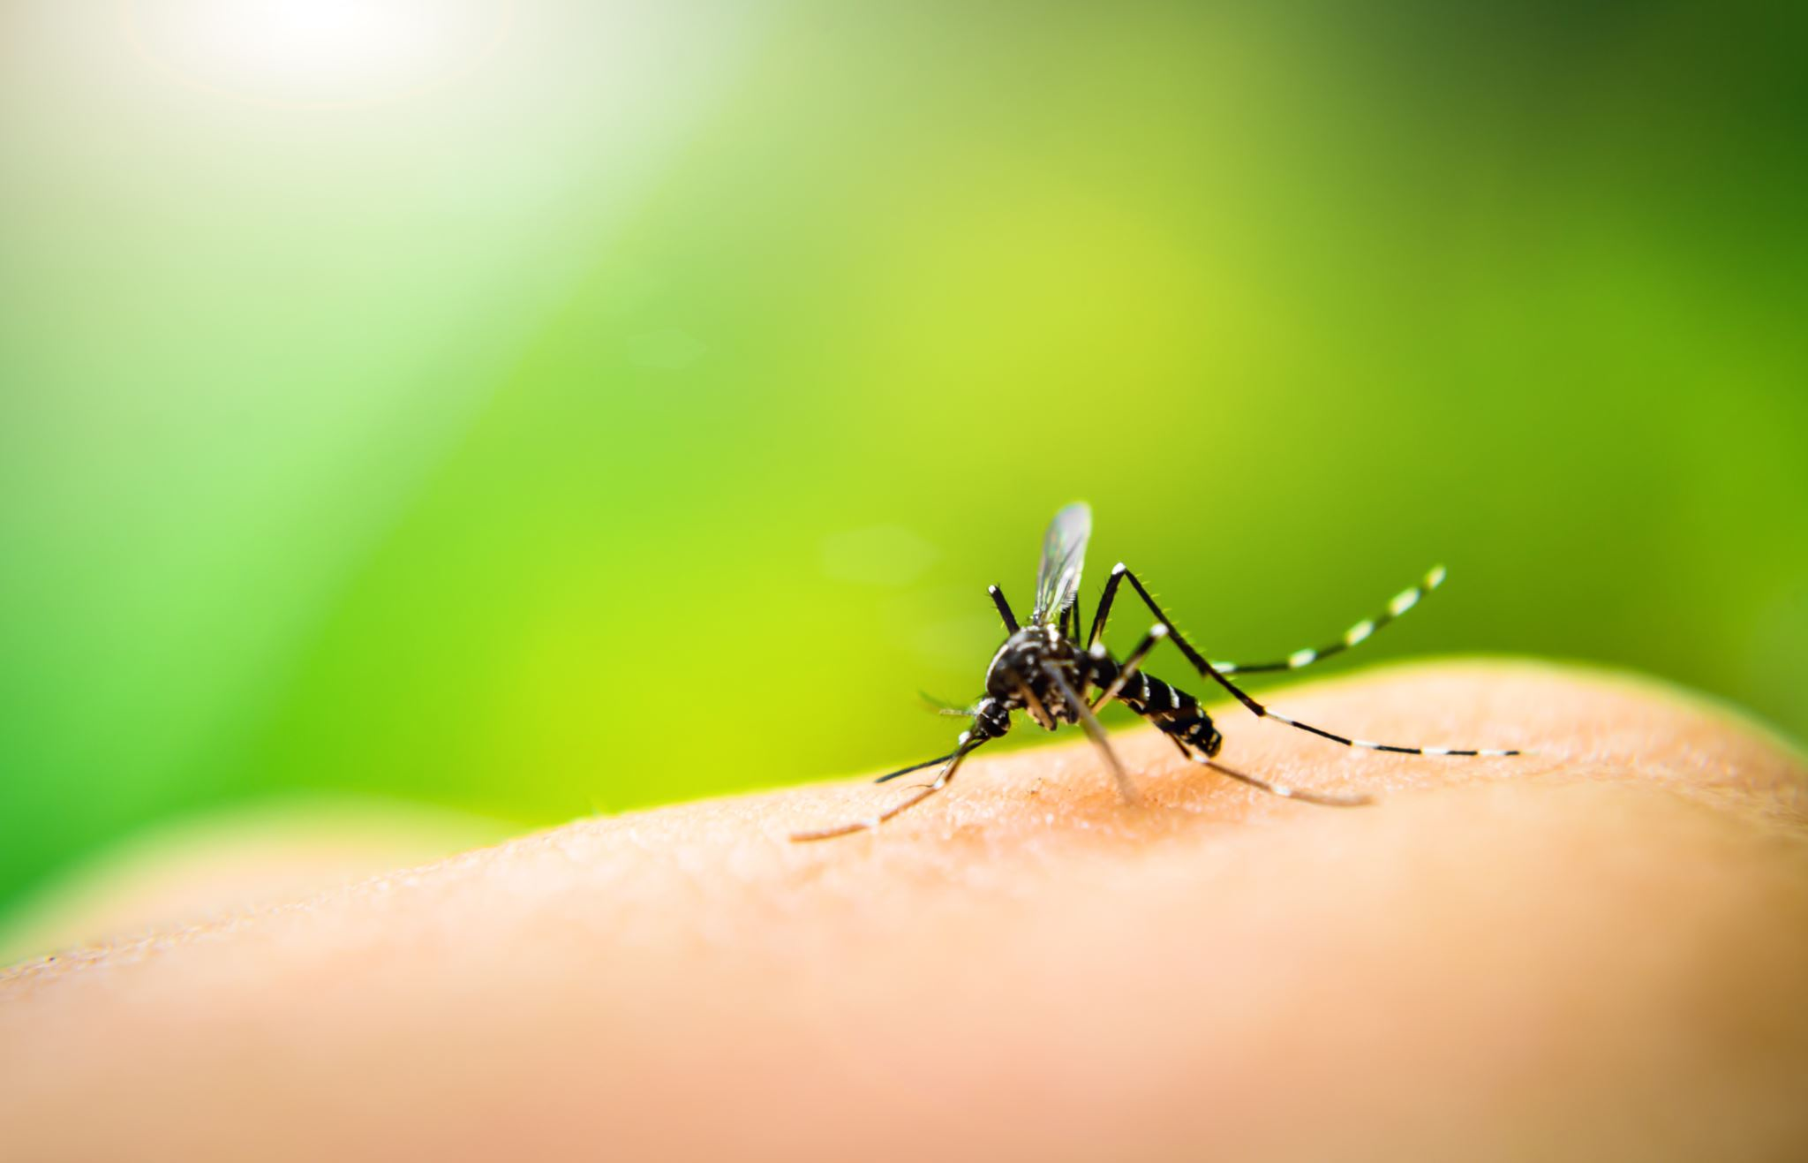 | Hear about a new funding opportunity?  Please email the EIS Program Coordinator.

Program Awards
EIS Student Leadership Award  Recognizes excellence in EIS graduate students who play a leadership role within the EIS program. |  | EIS Student Education Award  Recognizes an EIS graduate student who has excelled in education. Educational excellence can be achieved in any mix of TAships, laboratory mentoring, and outreach. |  | Carruth Award  Recognizes an EIS graduate student who has completed exceptional work, as demonstrated by their annual Progress Report.
Award Allocation

One award per year which includes a cash award
Award Committee
The EIS student leadership award committee will consist of 2-3 EIS graduate students and one EIS faculty member. The Program Chair and the Student Executive Committee Member will jointly nominate the members of the committee. The EIS student education award committee will consist of 1 EIS graduate student and 2 program faculty. The Program Chair and the Student Executive Committee Member will jointly nominate the members of the committees. |  |  |  | The award is allocated by the EIS Advisory Committee, a standing committee of four EIS faculty members that reviews the annual Progress Reports.
Award Nominees

Students can self-nominate or be nominated by others for either Leadership or Education awards. The student then writes the application. The EIS Program Coordinator will send out a request for nominations, usually in the spring semester. |  |  |  | All students completing Progress Reports are automatically nominated for the Carruth Award.
Award Application

Applications should not exceed one page and should describe the achievements that make the student eligible for the award. |  |  |  | The award application is the Progress Report submitted by each student.

Important Links

Academic Resources

Graduate College
Provides information on Graduate College policies, contacts, information about resources, deadlines, and other useful information.

Graduate Student Academic Services (GSAS)
The Graduate Student Academic Services (GSAS) Office within the Graduate College is here to help students, faculty, and staff keep track of academic progress and the steps needed to complete a graduate or professional degree. Information on dates and deadlines can be found here.

Graduate Center
Serves as a hub for resources important to graduate students and postdoctoral fellows.

International Student Services
International graduate students in need of guidance, particularly in regard to travel and immigration.



UArizona Libraries
For library information, resources, and help.

Borrow Technology
Students in need of technology or equipment can check out items through the library.

University Information Technology Services (UITS)
UITS is available online to help with technological needs and support. Visit for their full range of services.

Office of Student Computing Resource (OSCR)
The Office of Student Computing Resource is now providing software assistance online. OSCR consultants can assist and guide you on how to use software to finish your projects.

Student IT Center
The Student IT Center features online learning and teaching technologies, including tools for
collaboration and testing.

Writing Efficiency Sessions (WES)
WES are group writing sessions focused on productivity and output.

Summer Fellowship Application Development Program
The Summer Fellowship Application Development Program offers deadlines and writing support to assist UArizona students in completing fellowship applications over the summer.

Personal Resources

Quick Link for New and Current Students
Here you will find information about:  - Academic Services, Policies and Procedures  - Costs and Funding  - Professional Development  - Child Care Subsidies and Family Friendly Information  - Health, Wellness and Safety  - Other UArizona Resources & Information  - Third-party Information & Resources | 

Campus Safety & Wellness
Resources to enhance students’ safety and well-being. Including information on how to sign up for UA Alert to be notified of campus emergencies.

Campus Recreation
Included in your fees, it has three locations and open seven days a week.

Campus Pantry
The Campus Pantry aids students facing food insecurity. It has a new location and new hours
during the current campus closure.
Campus Health
Campus Health is a one-stop-shop for health and wellness. From medical, mental health, and wellness services, to events, workshops, and student groups, they’re here to support all students.

Counseling and Psych Services (CAPS)
Whether you’re ready to start counseling or medication, have a question, seeking community, want to learn new skills, or just need to vent, there’s a path for you. CAPS services are available to all enrolled University of Arizona students.
At Counseling and Psychiatric Services (CAPS) students can speak with licensed mental health professionals about things like:
• anxiety and depression
• eating and body image
• alcohol and drug concerns
• family, friend, roommate, and relationship problems
• sexual assault and relationship violence
• crises and trauma
• psychiatric medication
• And anything else you need to talk about.
Please call CAPS prior to going into the office. CAPS Main phone:
520-621-3334

Entomology & Insect Science Resources

Keys
Talk to your advisor about the keys you will need. Your advisor can tell the Entomology Dept. administration (currently Nirka Green) that you need a key to a particular room, and with the authorization you will receive, you can make the trek to the Key Desk north of Speedway to get keys.
Lab/Office Space
Your supervisor will assign you bench space in their laboratory. Students conducting research rotations may not be assigned individual bench space and instead may be assigned shared lab space for the duration of the rotation.
Your supervisor may also assign office space if there is some available. If your supervisor does not have adequate office space available, contact the EIS Program Coordinator for assistance.

University of Arizona Insect Collection (UAIC)
Over one million pinned and identified insects are curated in the University of Arizona Insect Collection (UAIC) located in Forbes building Room 410, next to the front offices of the Department of Entomology. The UAIC is a valuable resource for insect-related research projects, and it is a great place to deposit voucher specimens resulting from your research.
Contact Dr. Gene Hall (Collection Manager) for more information about the UAIC.

Meeting rooms
The 7th Floor Meeting Room (Marley 741H), Entomology Classroom (Forbes 412) and Entomology Library (Forbes 403E) can be reserved by phoning the Entomology office staff (621-1151), or by emailing Nirka Green.

Seminars
Entomology & EIS: Fridays at 11:00 am in the Marley 230 Lecture Hall. Fall semester only.
Ecology & Evolutionary Biology: Mondays at 3:00 pm and Tuesdays 12:30 pm

Listservs
As an EIS graduate student, you are automatically subscribed to the EIS student listserv:
eis-students@list.arizona.edu. You can email the address to send messages to all program students.
eis-faculty@list.arizona.edu is the listserv for all EIS faculty members.
ent@list.cals.arizona.edu is the listserv for all Entomology faculty and staff. Email Nirka Green to be added.
eeb@list.arizona.edu is the Department of Ecology and Evolutionary Biology. How to join: instructions

Graduate Student Learning Outcomes Assessment
As part of the accreditation process, and to measure whether students are achieving the learning outcomes desired, every academic program must have a “learning outcomes assessment.” It is important to stress that this assessment is not used to grade or judge the student; instead, the responses are used by the Chair and Executive Committee to analyze patterns of strengths and challenge areas for students across the program. Based on the abstracted, anonymous data, the faculty may then make changes to the program to address any issues that need to be addressed through the curriculum. In 2023, upon consultation with the Office of Instruction and Assessment, the Executive Committee of the EIS Program revised the Assessment Rubric consistent with the goals of the program. Specifically, a quantitative 5-point scale for proficiency for learning outcomes was replaced by qualitative responses (by faculty) and self-reflection prompts (for students), more appropriate for a program with ~25-30 MS and PhD students.
MS Assessment  MS students will complete a self-reflection survey after:  Final thesis defense |  | PhD Assessment Activities  PhD students will complete a self-reflection survey after each of the following:  - Oral comprehensive exam  - Final dissertation defense

The EIS program has three learning outcomes. The first asks about the student understanding of insect biology (content learning outcome), the second asks about whether the student can think critically and creatively to perform and analyze research (the research learning outcome) and the third asks whether the student can communicate the research findings and the context for the research (the communication outcome). At a MS final defense, the student will be asked to reflect on their strengths and weaknesses with respect to all three learning outcomes. At a PhD oral comprehensive exam, the student will be asked to reflect on their mastery of discipline content (learning outcome 1). At the PhD final dissertation defense, the student will be asked to reflect on their research and communication skills (learning outcome 2 and 3).

Expected Student Learning Outcomes
- Discipline content: The student demonstrates understanding of key concepts in insect biology as well as those underlying their general subject area (e.g. physiology, molecular biology, genomics, ecology, systematics, evolution or behavior).
- Research: The student exhibits a) critical thinking skills to evaluate scientific literature and articulates how their research fits into and advances the discipline. The student b) develops creative and innovative research ideas and approaches. The student c) uses multiple research approaches to collect scientific data related to their research area, and can interpret, analyze and critique their data.
- Communication: The student communicates their research (importance, approaches taken, summary and interpretation of results) effectively through oral presentation and can express the potential impact of their work on society in lay terms.

Appendix 1: Student Appeals
All students of the EIS GIDP have the right to appeal decisions which impact their academic standing.

Graduation Requirements
Appeals for changes in the graduation requirements can be made to the Program Chair and will be considered at the next Executive Committee meeting.

Course Grades
University policy for grade appeals can be found under Grade Appeal in the University’s General Catalog.

Unsatisfactory Academic Progress
Students who receive notification of unsatisfactory progress from the Advisory committee will be given an opportunity to appeal the actions and/or deadlines required to prevent program termination as dictated by the committee. Appeals can be made to the Program Chair and will be considered at the next Executive Committee meeting.
In any case, should a student feel that there is a conflict of interest that may interfere with the objective review of their appeal, this issue should be raised with either the Program Chair or the Program Coordinator.

Grievance Policy
Should a graduate student feel he or she has been treated unfairly, there are a number of resources available. With few exceptions, students should first attempt to resolve difficulties informally by bringing those concerns directly to the person responsible for the action, or with the student's graduate advisor, the department head, or the immediate supervisor of the person responsible for the action. If the problem cannot be resolved informally, the student may be able to file a formal grievance.
For additional information: https://grad.arizona.edu/policies/academic-policies/grievance-policy#grievance-responsibility



Appendix 2: Progress Report Format
Note: Progress Report Format is subject to change – when completing your report, use the format provided by the Program Coordinator in the spring semester.
